

**Assignment 2: FIT3179 Data Visualization**

**Singapore’s Public Transport System**

[**https://dtwjy.github.io/Visualisation2/**](https://dtwjy.github.io/Visualisation2/)

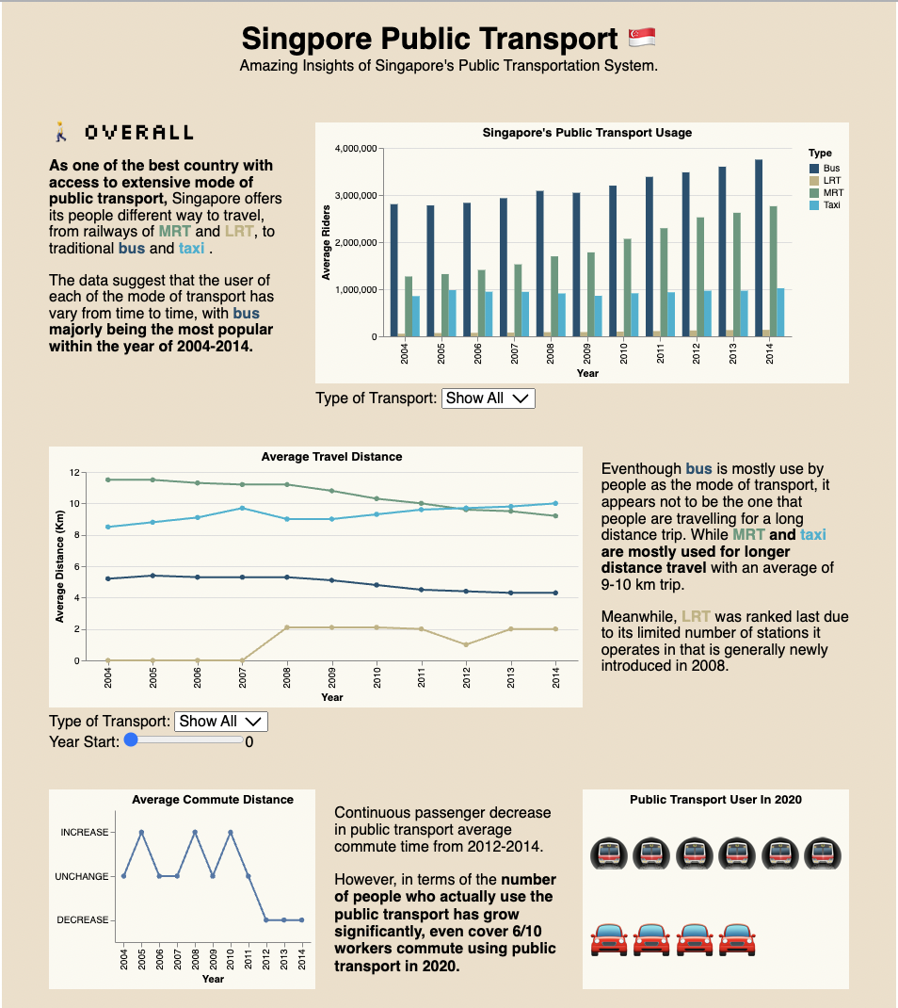

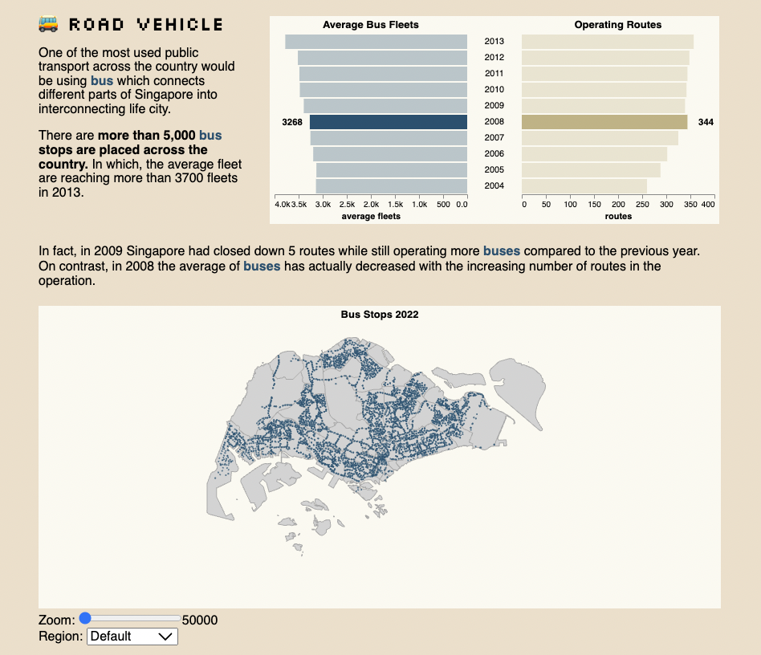

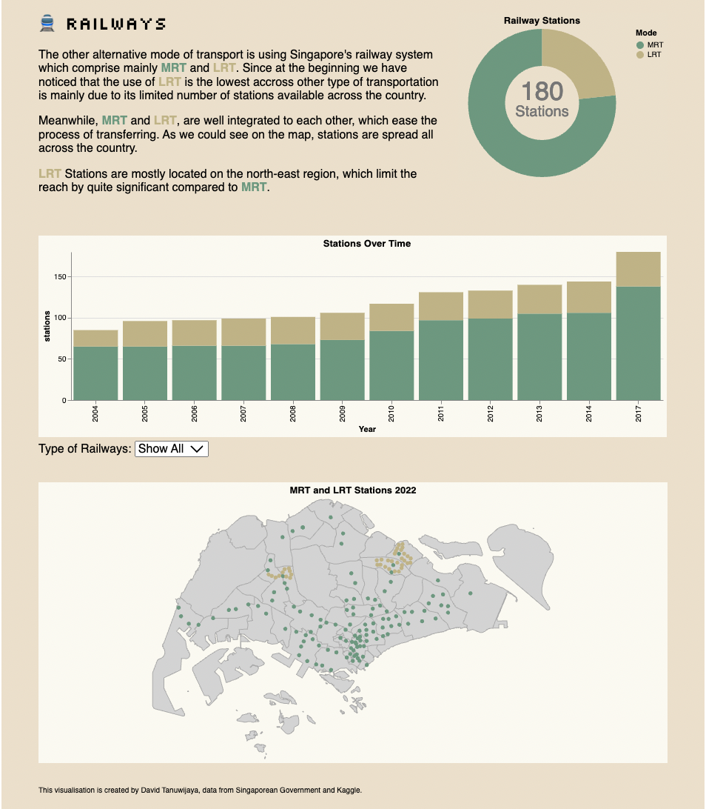

Name : **David Tanuwijaya**

Monash ID : **32156553**

Tutorial : Wednesday, 1 PM

Word Count : 996 (excluding figure caption, appendixes, and references)

**Why and Who**

The visualisation aims to present and depict interesting facts about Singapore’s public transport system which are recognised as one of the best systems in the world (Tillman, 2022). Overall, the fact was displayed in various types of graphs and statistical figures to view the data from different perspectives. The visualisation is mainly divided into 3 different sections of the broad overview/introduction, road vehicles, and railways system.

**What**

The data was derived from the Singapore’s Government of Public Transport department and other supportive public dataset from Kaggle for coordinate dataset (Xuan, 2019; Aun 2021). Most graphs are having a table type dataset, with combination of quantitative attributes with categorical variables assessed for each stations’ name and mode of transportation. Some of the information are presented in an ordinal way such as year and count data. Additional data for Isotype are manually created using data based on news of Straits Time (2020).

**Why and How**

1. Public Transport Usage

As to the introduction of the topic on the country’s public transport system, we could assess the significancy based on the qualitative attribute of the count of average riders of public transport users regarding different type of transportation available, in this case MRT, LRT, Bus, and taxi. Colour are used to categorise each rider to different mode of transport as seen on the Figure 1. Filter function is available for user to use select specific type of transportation.

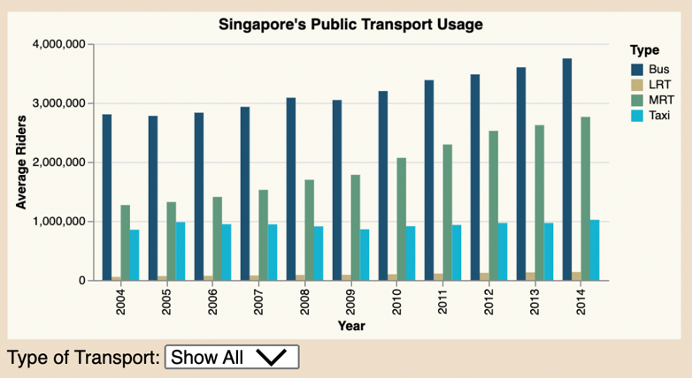

Figure 1: Singapore’s Public Transport Average Riders

1. Average Travel Distance for each Mode of Transport

Line chart is used in Figure 2 to easily capture the changes happened over time on the average travel distance made by passenger for each different type of transportation. Color is used consistently to represent the different mode of transport as a categorical variable. Y axis would be the average travel distance in kilometres as quantitative attributes. Interactive slider and filter drop down menu are available for user to further analyse the data type and starting year.

Figure 2: Line chart of average travel distance by each mode of transportation from 2004-2014

1. Bump Chart

Visualises the average distance changes overtime, whether an increase or decrease in travel distance are being observed across the country. Bump chart (Figure 3) allows user to capture the change easier, with a straightforward indicator of increase or decrease line chart with point on each year.

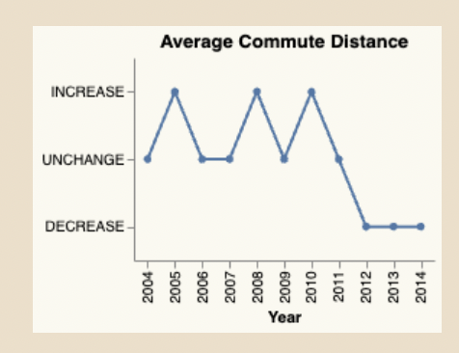

Figure 3: Bump chart of average commute distance within the year of 2004-2014

1. Isotype

Simple illustration of car to represent private transportation and train as a public transport has uniquely represent that 6/10 worker in Singapore use public transport to commute in 2020 (Auto, 2021). Figure 4 uses emoji as its mark to give the appeal to user.

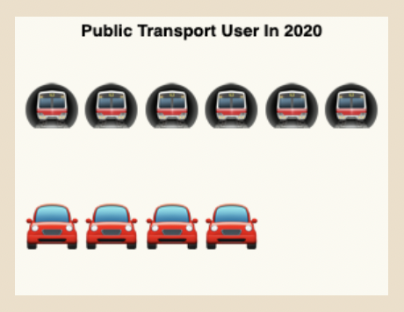

Figure 4: Bump chart of average commute distance within the year of 2004-2014

1. Average Bus Fleets vs Operating Routes

Moving to the next part of the visualisation, where we take a closer look into the road vehicle options of Bus and Taxis. This segment mainly demonstrates how the operation of bus lines are improved every year from year to year, with some interesting facts worth to analyse.

In this case, the double-sided bar chart compares the number of average bus fleets and the actual number of routes in operation during a particular year (Figure 6). Both graphs, y axis contains the year as a nominal attribute, while x axis provides a quantitative measure of both different values of average fleets and number of operating routes. Highlighted value is being on the 2008, where adverse changes occurred.

Figure 5: Average Bus Fleets vs Operational Bus Routes over the years

1. Map of Bus Stops and MRT locations

The visualisation depicts the distribution of public transport access for each type of transport. We could see that the distribution of bus stops is generally equally spread out, while for LRT only have few stops located mainly the north-east region.

In this case, data was mostly being categorical with a coordinate quantitative value in it that is being mapped to the topo-jason object. The colour represents type of transportation, equipped with zoom feature to allow user to focus more into a specific region of the country as suggested on Figure 6.

Figure 6: Map projection of the location of public transport across the country (MRT, LRT, Bus)

1. Donut Chart

Donut chart is used in Figure 7 to compare the number of stations of MRT and LRT, which in this case was proven to be significant. The colour signifies the MRT and LRT (categorical), while the size of the donut represents the proportion of stations count (quantitative attributes). Additional annotation was made in the centre of the donut to give a quick total of how many stations are there in the country.

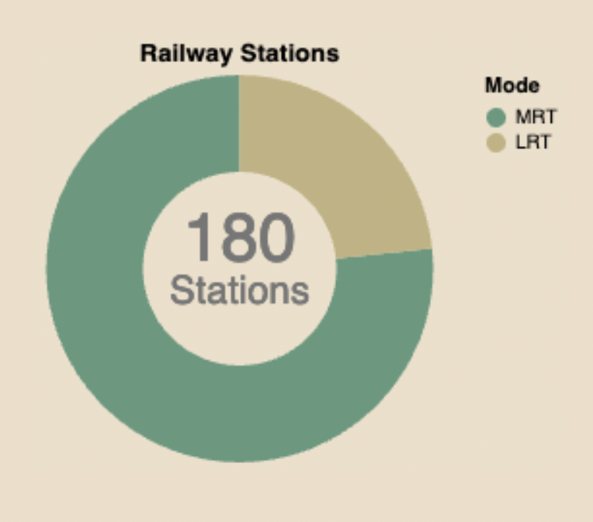

­­

Figure 7: Proportion of number of MRT and LRT stations in 2017

1. The visualisation of the stacked bar chart is used to continue the storytelling part of the previous donut chart, given the number of station changes over the year. This provide user more information of how the railway line has been developed for the past years. Y axis being the quantitative attributes of the station count, while x spreads year as part of the categorical, ordinal attributes (see Figure 8 below). Filter is provided allowing user to be able to select a particular type of railway type to be displayed individually as a bar chart. Colour is used to differentiate the type of public transport selected.

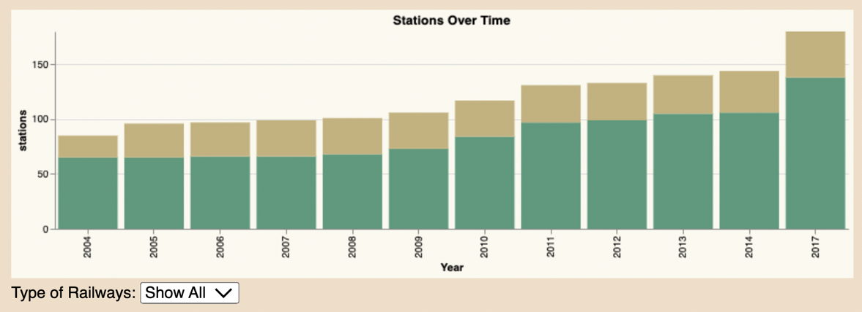

Figure 8: Proportion of LRT and MRT stations across the year of 2004 - 2007

**Dashboard Design**

The overall layout of the visualisation is mainly divided into 3 sections. All the section was explained with at least one visualisation and graph description. Text arranged symmetrically and consistent layout throughout.

The visualisation majorly uses the earthy colour scheme of green, light grey, brown, blue, and light blue to capture the natural part of the transportation which supposed to be part of humans need as a social wellbeing. Overall, the colour is consistent throughout the visualisation with clear usage of highlighted crème panel background to display each of the visualisation as a container. Colours are also used in some of the text descriptions to indicate the relationship between the data and its description. White space is also well balanced toward the separation for each line of text and visualisation.

Consistent Helvetica typeface is being used as the main font of the visualisation to give a clear, easy to read appeal. The heading uses special character downloaded from the Google font, to appear as a pixelated text that was mainly visible on public transport stations’ screen. Text weight, size, and colour differentiation are used to emphasize important information related to the relevant graph. Graphical elements such as emojis are used in the title of the visualisation and sized accordingly to create visual cue and aesthetic reasons.

The overall infographic and text is strategically placed to be read from left to right, with clear layout that assist user to understand the context, furthermore informative tooltips are equipped when hover across different visualisation.

**Appendix**

Five Design Sheet

Sheet 1

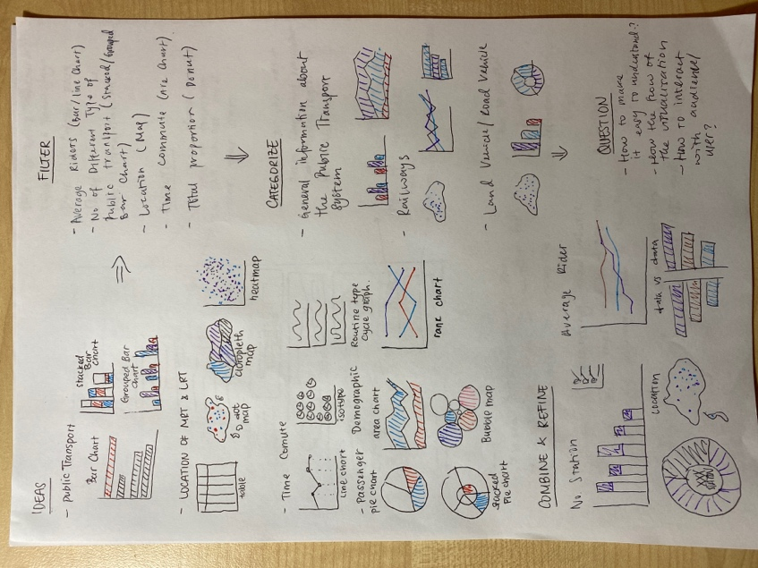

Sheet 2

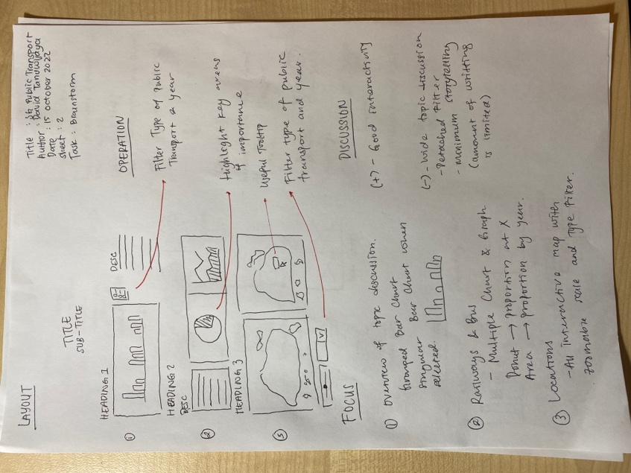

Sheet 3

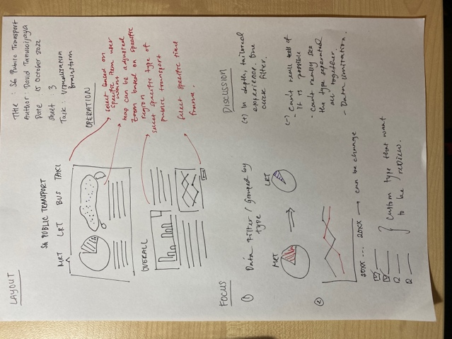

Sheet 4

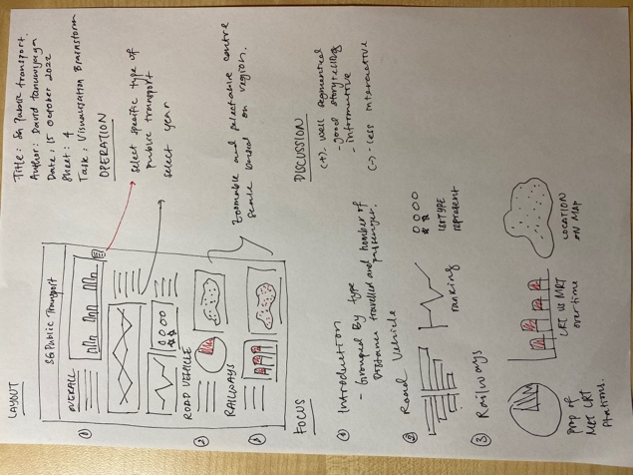

Sheet 5

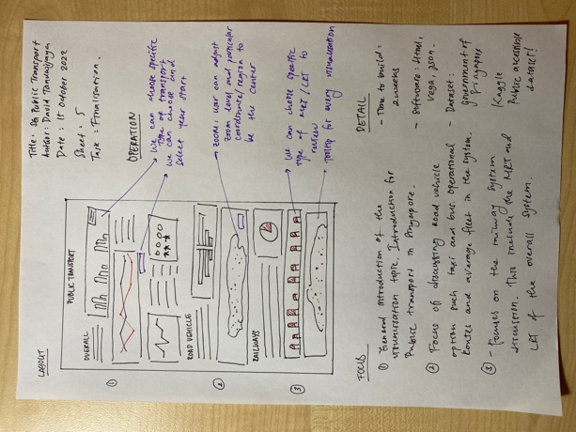

**References**

Aun, L. C. (2021, May 28). *List of bus stops in Singapore*. Observable. Retrieved October 1, 2022, from https://observablehq.com/@cheeaun/list-of-bus-stops-in-singapore

Auto, H. (2021, June 18). *More s'pore residents take trains and buses to work, fewer drive to the Office: Population Census*. The Straits Times. Retrieved October 1, 2022, from https://www.straitstimes.com/singapore/more-spore-residents-take-trains-and-buses-to-work-fewer-drive-to-the-office-population

*Singapore Open Source Database*. Data.gov.sg. (n.d.). Retrieved October 1, 2022, from https://data.gov.sg/dataset

Tillman, C. (2022, August 22). *One of the best worldwide: Singapore's transport system*. Rapid MTS. Retrieved October 1, 2022, from https://www.rapidmts.com/singapores-transport-system/#:~:text=A%20popular%20travel%20website%20based,up%20to%200.9%20m%20tall.

Xuan, L. Y. (2019, August 3). *Singapore train station coordinates*. Kaggle. Retrieved October 1, 2022, from https://www.kaggle.com/datasets/yxlee245/singapore-train-station-coordinates